This week, you will submit a video presentation. Your presentation must include both audio and visual components and be professional in nature.

You will submit your final presentation here for grading, and you will submit it to the discussion board this week as a draft for your peers to review and as a final product to share. See the discussion board for details

Choose a topic below.
Taken from the assigned reading in Butts chapter 12, page 401, "Ethical Reflection: Typical Unethical or Illegal Behaviors in Organizations"
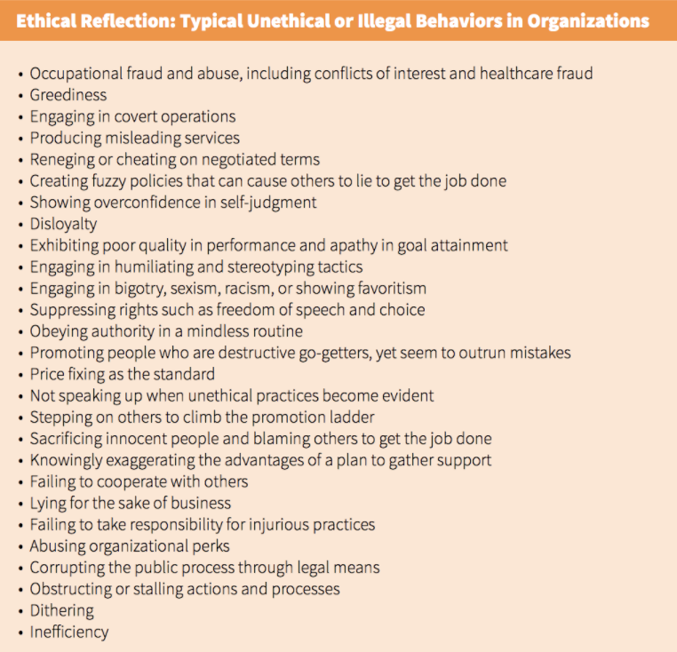
MY TOPIC IS FAILING TO COOPERATE WITH OTHERS

Create a presentation of 10-15 slides or screens excluding the title and references.
Your slides/screen should include titles, main ideas, bullet points, and relevant images, charts, graphs, etc.
In your presentation:
Describe an ethical situation, based on the chosen topic, that can get in the nurse's way of practicing ethically. Describe the situation clearly and concisely.
Identify how this situation relates to one provision within the Code of Ethics for Nurses.
Identify two ethical principles that may arise when facing this situation.
Discuss how a nurse might lessen the impact of the situation on the nurse's practice.
In addition to the course texts, cite and reference a minimum of two (2) additional scholarly sources to support your work.
Close with a summary of your topic, and APA formatted reference slide(s).
Review the rubric for further information on how your assignment will be graded.

BUTTS CHAPTER 12 PAGE 401

Organizational Culture and the Ethical Climate
Organizational culture refers to an organization’s past and current shared assumptions, experiences, and philosophy, much like a tribe with its own “language, stories, beliefs, assumptions, ceremonies, and power structures” (Johnson, 2012, p. 319). Daft (2004) presented several types of organizational cultures and indicated a potential for every culture to be successful. No matter which culture is promoted by the organization’s leaders, the culture needs to fit with its strategy and environment.
Organizational ethics is a broad concept that includes not only culture, but also the processes, outcomes, and character and denotes “a way of acting, not a code of principles … [and] is at the heart, pumping blood that perfuses the entire organization with a common sense of purpose and a shared set of values” (Pearson, Sabin, & Emanuel, 2003, p. 42). The ethic of an organization refers to an organization’s attempt to define its mission and values, recognize values that could cause tension, seek the best solutions to resolve these tensions, and manage the operations to maintain quality and the organization’s values. The ethics process serves as a mechanism for organizations to address ethical issues regarding financial, business, and management decisions. Organizations are systems, which means that an organization consists of highly integrated parts or groups to accomplish shared goals. A complex adaptive system, such as a healthcare organization, focuses on external relationships, which places the organization within a larger context or environment (Boyle et al., 2001).
Ethical Reflection: Daft’s Types of Organizational Cultures
1. Adaptability culture: The focus is on the external environment where innovation, creativity, risk taking, flexibility, and change are the key elements for success. This type of organization creates change in a proactive way in an effort to anticipate responses and problems. Examples are e-commerce companies such as Amazon.com and Buy.com, which are required to change quickly in anticipation of customers’ needs.
2. Mission culture: The vision and goals are clearly focused on a high level of competitiveness and profit-making strategies. In this type of culture, executives and managers strongly communicate a strategic plan for the organization’s employees and expect high productivity, performance goals, and fringe benefits for goal attainment. An example is PepsiCo.
3. Clan culture: The focus is on employee needs and the strategies employees can engage with for high performance. Key values in this culture consist of leaders taking care of their employees and making sure they have appropriate avenues to satisfaction and productivity. Responsibility and ownership are other key values in this type of culture. Rapid change occurs in this environment because of changing expectations from the external environment. One example is the MTW Corporation, which sells web-based software and provides consultation to state governments and the insurance industry.
4. Bureaucratic culture: The focus is primarily on the internal environment, where stability is a mainstay. Leaders develop and carry out scrupulous and detailed plans in a cautious and stable environment with slow-paced change. In this environment, personal engagement and involvement are not cultivated; instead, there is a high level of consistency, conformity, efficiency, and integration. Because of the inflexibility of this culture, many organizations are forced to change to a different, more adaptable culture. One successful organization with this type of culture is the Pacific Edge Software company, run by a husband-and-wife team, which thrives on order, discipline, and control.
Source: Adapted from Daft, R. L. (2004). Organizational theory and design (8th ed., pp. 367–370). Mason, OH: South-Western.
An organizational citizenship represents what society and communities expect from open systems (Johnson, 2007). The expectations are part of establishing and maintaining those external relationships, including those with suppliers, regulatory bodies, customers, allies, competitors, communities, and society as a whole. For an organization to be characterized as being a good citizen, it must anticipate ethical issues or conflicts in external relationships then engage in dialogue and activities to manage those concerns.
Even though the term organizational ethics often refers to an organization’s image, people who work in the organizations are the ones who behave ethically or unethically and therefore shape the ambiance and character of the organization. The following box has a list of unethical and illegal behaviors in which one could engage within organizations; the list is not exhaustive, but it includes the more common behaviors. Many unethical behaviors of organizations are also illegal, so sometimes the lines between ethical and legal behaviors are blurred.
Ethical Reflection: Typical Unethical or Illegal Behaviors in Organizations
• Occupational fraud and abuse, including conflicts of interest and healthcare fraud
• Greediness
• Engaging in covert operations
• Producing misleading services
• Reneging or cheating on negotiated terms
• Creating fuzzy policies that can cause others to lie to get the job done
• Showing overconfidence in self-judgment
• Disloyalty
• Exhibiting poor quality in performance and apathy in goal attainment
• Engaging in humiliating and stereotyping tactics
• Engaging in bigotry, sexism, racism, or showing favoritism
• Suppressing rights such as freedom of speech and choice
• Obeying authority in a mindless routine
• Promoting people who are destructive go-getters, yet seem to outrun mistakes
• Price fixing as the standard
• Not speaking up when unethical practices become evident
• Stepping on others to climb the promotion ladder
• Sacrificing innocent people and blaming others to get the job done
• Knowingly exaggerating the advantages of a plan to gather support
• Failing to cooperate with others
• Lying for the sake of business
• Failing to take responsibility for injurious practices
• Abusing organizational perks
• Corrupting the public process through legal means
• Obstructing or stalling actions and processes
• Dithering
• Inefficiency
Source: Boyle, P. J., DuBose, E. R., Ellingson, S. J., Guinn, D. E., & McCurdy, D. B. (2001). Organizational ethics in health care: Principles, cases, and practical solutions (pp. 19–20). San Francisco, CA: Jossey-Bass/John Wiley & Sons.
The ethical climate, which plays a large role in shaping the culture, is formed by the way the organization responds to ethical issues and challenges. The ethical climate is defined as the organizational members’ shared perceptions of their values related to how ethical decisions are made on the issues of power, trust, and human interactions (Johnson, 2012). Numerous researchers have studied the idea of an ethical climate, but Victor and Cullen (1987) were the first to discover then reconfirm that organizations can have a combination of one or more of these five dimensions of ethical climates:
• Caring: Interested in team values and goals, well-being of others, and friendships
• Law and code: Guided by professional codes of conduct
• Rules: Strict adherence to policies and procedures
• Instrumental: Focused on self-interest and company profits
• Independence: Focused on personal moral beliefs and decision making
The instrumental climate manifests from self-interest gains and profits within organizations and poses more serious ethical problems than any of the other ethical climates (Johnson, 2012).
Organizational Integrity and Trust
Organizational integrity generally means that good and right behavior in relationships is found across the whole system (Brown, 2006). Integrity as a whole is equated with the following:
• Keeping consistency between what an organization does and what it says
• Maintaining mindfulness of relationships with others
• Listening and including all voices, whether disagreeable or not, in everyday business practices
• Having a collective worthwhile purpose
Most major relationships transpire within five dimensions of organizational life: cultural, interpersonal, organizational, social, and natural. Integrity and trust go hand in hand; organizations and leaders with integrity are also trustworthy.
Trust is a multifaceted virtue that serves as an umbrella over the key values in organizations. Shore (2007) stated that organizational trust is the essential ingredient—what he labeled as the lubricant—that facilitates everyday business and interactions. People can trust other people to follow through on their work and commitments, just as people in the community can depend on organizations to uphold their words and promises. Fiduciary relationships hold a high value in organizations because these relationships represent a formal duty to another or others, imposed by loyalty, commitment, and organizational structure, which means that people place trust in others to carry out activities related to their position with morally good judgment.
Trust only flourishes in organizations when there is evidence of fairness. Victor and Cullen’s (1987) descriptions of the cultures of caring, law and code, and rule enable the achievement of fairness and justice. Practicing the virtue of justice promotes fair distribution of resources (of any type) among the individuals within the organizations and in the external community. According to Gutmann (1995), an organization must practice and sustain two principles so the community it serves can have a sense of fairness: (1) nondiscrimination in the moral standing of each person, and (2) nonrepression, so that each person has a deliberate voice if they so choose. Without those principles, an organization’s trust and justice will be questioned.
The ethic of the organization defines the mission and values. Some of those values are teamwork, community, achievement, competence, knowledge, innovation, having fun, valuing diversity, and encouraging others. Organizations need to define their values operationally, and they likewise must define their ethical practices in writing and in verbal communication. Jack Welch, past chairman and CEO of General Electric, once said: “Good business leaders create a vision, articulate the vision, passionately own the vision, and relentlessly drive it to completion” (as cited in Kovanic & Johnson, 2004, p. 101).
As evidenced in many corporate scandals, trust in organizations has been eroding for years, and now it is at an all-time low (Jennings, 2006; Shore, 2007). Healthcare organizations are similar. The rapid transformation in healthcare organizations has been a contributing factor in the erosion of trust. As organizations rapidly change to comply with regulatory standards, costs, the demands of internal and external stakeholders, and the needs of the populations they serve, the ethical questions that need to be answered have become more difficult to resolve. Abusive executive power and self-serving corporate decisions lead to unethical behaviors, which leave an air of mistrust within the organization and in the external community. Trust in organizations is an obscure concept that consists of a network of convoluted relationships, although researchers have found that trust critically matters in organizations for nurses and other healthcare personnel because of the following (Kramer & Schmalenberg, 2002; Laschinger, Shamian, & Thomson, 2001):
• Trust promotes economic value within organizations.
• Trust increases strategic alliances, teamwork, and productivity.
• Nurses and other healthcare personnel experience a more positive practice environment as a result of trust.
• Nurses experience increased empowerment, autonomy, and overall job satisfaction because of organizational trust.
A violation of trust in organizations will prompt verbalizations, such as angry and sarcastic remarks by personnel, especially if trust has been previously entrenched throughout the organizational levels. A violation of trust in organizations is generally illegal and less forgivable than in a personal relationship where trust historically exists between two people.
There are logical reasons for the way people perceive organizations. Untrustworthy leaders of organizations could have been engaging covertly in unethical or illegal behaviors for a long while, and if left unchecked it will result in the ethical collapse of the organization.
Jennings’s Seven Signs of Organizational Ethical Collapse
Jennings (2006) identified seven signs of ethical collapse and detailed how organizations can conduct business ethically and sustain its core values. The signs of collapse are the same whether the organization is for-profit or nonprofit, though there is some variation in the unethical activities. The signs are as follows:
1. Pressure to maintain numbers
2. Fear and silence
3. “Young ‘uns and a bigger-than-life CEO”
4. Weak board
5. Conflicts
6. Innovation like no other
7. Goodness in some areas atones for evil in others
When these signs of ethical collapse are present, Jennings indicated that an organization is in profound trouble. An explanation of each sign follows.
Pressure to Maintain Numbers
The first and earliest sign that the organization is in trouble is an obsession to maintain numbers, as measured in quantifiable goals (Jennings, 2006). Numbers drive nonprofit and for-profit organizations.
Fear and Silence
In organizations about to collapse ethically, there is an air of fear, silence, and servility (Jennings, 2006). Organizations are on the road to ethical collapse when there is corruption and wrongdoing by administrators. Many times administrators prefer looking for gray ethical or legal areas so they can manipulate or create confusion or vagueness in records, bookkeeping, and other areas in the hopes that they will conceal their behavior and not be caught. Even in the midst of an ethical meltdown, not many people challenge the workings of the organization for fear of being threatened, publicly shamed, dismissed, or demoted. Employees and administrators who have evidence of confusing, fuzzy bookkeeping or wrongdoing are silenced and sometimes bribed by those involved with unethical, and perhaps illegal, conduct. Fear of not fitting in or not being a team player is often a reason for employees’ silence.
Young ‘Uns and a Bigger-Than-Life CEO
The third sign of an ethical meltdown involves a CEO who is sometimes a generation or two older than the other members of the organization and is lavishly praised and held in high regard by the community and media (Jennings, 2006). To maintain this level of admiration, these CEOs surround themselves with extremely driven young people, sometimes their own sons or daughters, who vow loyalty to the CEO and the organization. The presence of a highly regarded CEO does not necessarily translate to legal and ethical problems in an organization. However, when problems do exist or when employees see potential trouble coming, they or others hesitate to ask questions that could cause embarrassment to the bigger-than-life CEO. The sentiment is, “we don’t ask questions.”
Weak Board
A weak and inefficient institutional board of directors is the next sign of an organization on the edge of ethical collapse (Jennings, 2006). Several reasons for a weak board exist, alone or in combination. Sometimes the board is composed of inexperienced members who are the CEO’s cronies or are unwilling to confront the beloved CEO. The members may be inefficient and unreliable, such as not spending enough time prudently thinking about and interpreting issues, not attending meetings, and not fulfilling their obligations to the board. Weak board members often make decisions that are baseless and push the limits on ethical and legal matters.
Conflicts
Conflicts of interest can occur with the individual or organization or between the internal organization and the external community (Jennings, 2006). Executives or board members engaged in a conflict of interest must have used their position to benefit themselves in some way at the expense of the organization.
Innovation Like No Other
Organizations heading toward ethical collapse often have extremely high levels of innovation and achievement (Jennings, 2006). They are often successful, with unmatched performance that seems to defy the laws of gravity with unlimited gains and with the philosophy that they are above the law. Organizations with rapid, extreme success continuously seek new ways of keeping the success up, no matter what tactic has to be used. Eventually, as these successful organizations face strong competitors with higher quality and, in the case of healthcare organizations, better outcomes for patients while also maintaining a healthy financial bottom line, they are at risk of falling. However, Jennings (2006) emphasized that just because an organization has innovation and extreme success does not mean it is on the verge of an ethical collapse. Some do collapse, but the collapse is linked to organizations never forming or practicing standards of ethical excellence that make up a healthy ethical climate.
Goodness in Some Areas Atones for Evil in Others
Some organizations and CEOs, especially in for-profit companies, are committed to the community, to public service, and to philanthropic activities, but sometimes this results in the philosophy that goodness in some areas (public philanthropy) atones for evil in others (unethical practices) (Jennings, 2006). Sometimes nonprofit organizations, when acting as a noble public servant, such as giving back to the community with an emphasis in environmentalism and human rights, also manifest the good atoning for evil philosophy, but Jennings contends that goodness in some areas will not overcome the improprieties in others.

REFERENCE FOR BOOK

Butts, J. B. (2015). Nursing Ethics. [VitalSource Bookshelf]. Retrieved from https://online.vitalsource.com/#/books/9781284099096/

